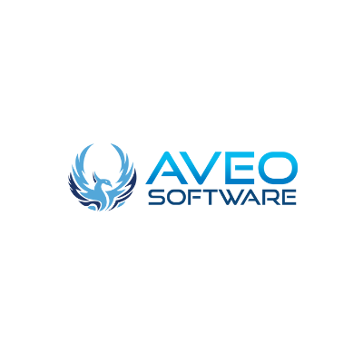

[How to convert your native Android and iOS apps to Flutter](https://aveo-software.tumblr.com/post/683405259611226112/how-to-convert-your-native-android-and-ios-apps-to?is_related_post=1)

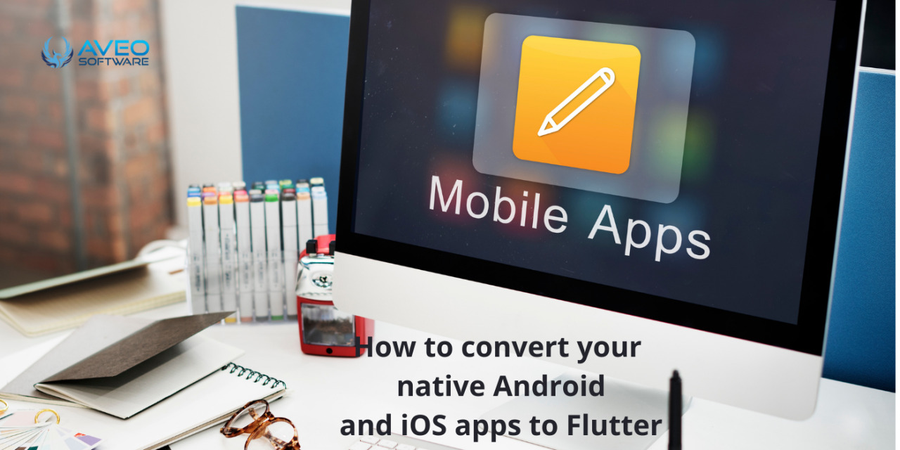

“However, I already have Android and iOS apps; why do I need Flutter?” After reading this blog article, the solution will be obvious — to save time and money.

“I recognize Flutter’s advantages, but I can’t afford to ditch my current projects and start over with Flutter.”

You won’t be required to! In this blog post, we’ll show you how to add new updates to your existing Flutter code.

Switching to Flutter as a Business Case

Think about the following scenarios:

Both the iOS and Android apps are being rebuilt from the bottom up.

You’re starting from scratch with one app.

You’re adding a new feature to one or both of your apps.

Think about the first scenario. It’s time for a major update or a complete redesign of your Android and iOS apps. This is a fantastic time to use Flutter. By employing this cross-platform development solution, you can cut your development resources in half, as you’ll only need one development and QA team instead of two. This frees up time for your second resource team to work on other projects. Furthermore, when compared to a native language development environment, development resources are typically 10% more efficient. When

compared to the traditional native language strategy, this corresponds to a 55 percent reduction in resources. The code size and runtime speed are equivalent to native language programmes. The only drawback is that you’ll have to learn Dart, a new programming language. It’s simple to understand, yet it could lower your initial Flutter venture’s 55 percent resource savings. During the first development cycle, it’s a good idea to budget for a 50% reduction in resources.

In the second case, you have an app that needs to be redesigned for both Android and iOS. Is it better to use Flutter versus a native app language like Swift or Kotlin? Flutter is a terrific choice, even if you only want to make one app. You will have more options in the future if you use Flutter in the creation of your new app. You have the option of replacing your current app right now or waiting for the next update. After the next refresh, your development time will be nearly nil. The look and feel of both applications will be identical. From then on, all development and maintenance will be able to take use of true cross-platform capabilities.

The final example is a little more subtle. You have two apps written in their original languages that don’t need to be replaced or significantly improved right now; all you want to do is add features. Your first choice should still be Flutter. You can continue to use all of your existing native-language code while building new features in Flutter. We’ll go into a technical case study in the rest of this white-paper that shows how we did just that.

Flutter as an incremental method: a case study One of our clients came to us with a frequent request: to integrate a customer satisfaction survey into an existing app. In both the iOS and Android versions of the programme, this would necessitate the creation of a whole new user flow.

The codebases for the iOS and Android apps were massive, containing a variety of technical stacks. They started with Objective-C and Java, but Swift and Kotlin are now used for the majority of their work. The new features would need to be thoroughly tested, and the updated version would need to be sent to users in a timely manner.

Adding a survey appears to be an easy process. It only takes a new item in the main menu to redirect the user to a succession of extra pages with blocks of questions and a large “Submit” button. It must also include a page where the user is rewarded for taking the survey.

Traditionally, we would test both platforms with two developers (one for iOS and one for Android) and a QA engineer. Flutter simply requires a single development team, and current Android and iOS code can be reused. It is possible to create a new module and connect it into existing apps with ease.

What’s the deal with your fluttering? According to a Grid Dynamics blog post about Flutter, it has some really great advantages over a more traditional native approach. It has comparable speed and performance, but it is truly cross-platform. This means that code may be written once and used across multiple platforms, including the Web.

Following some preliminary study and a lengthy discussion with the client about the potential benefits and cons, our team decided to attempt to implement the required survey functionality using Flutter.

Let’s delve a little deeper into the details now.

The Flutter module is being added. First and foremost, Flutter must be integrated into existing apps. There are two options for doing so. The most obvious method is to start a new Flutter app with the flutter create command, then replace the produced runner projects with the current ones. However, this is a much more challenging strategy because we may need to make multiple changes to current projects, and if we miss something, everything would be ruined. It also forces you to relocate all of your previous projects into a Flutter project folder, which is usually a bad idea.

Flutter, fortunately, provides a workaround. We can construct a specific module using the flutter create -t module command. It creates a new project with a somewhat different structure from the previous one. Because it is introduced as an external dependency, the key advantage of this solution over the previous one is the ability to have a Flutter module separate from the main code. The technique is detailed on the official documentation page, and connecting and executing the Flutter module from an existing project takes only 10 minutes.

We can now move on to the next difficult issue: communication between the native code and the Flutter module, now that the problem has been handled.

Who should I hire for this job? If you don’t have any experience with the development process, [**hiring an app development business**](https://href.li/?https://aveosoftware.ca/)could be really advantageous. The agency’s developers will help you learn the basics, keep you updated on developments, and come up with creative ideas.

You can also look at the firm’s portfolio and client reviews on their websites to get a sense of the quality of their work. It will give you more faith in your decision.

Company that creates mobile applications Hiring a [**mobile app development company**](https://href.li/?https://clutch.co/profile/aveo-software#reviews)allows you to keep track of your progress. Individuals that are focused on their work or merely on their responsibilities may deliver an excellent and tasteful solution to your growth queries. When you work with the greatest mobile app developers, you can count on an endless supply of expert assistance for any and all questions relating to any and all disciplines.

Invest in a flutter developer. Another option is to [**hire a Flutter Developer**](https://href.li/?https://aveosoftware.ca/mobile-development/) directly, and given how effectively it works, Flutter app development is definitely worth considering. Hire the best flutter app developers (full-time or freelance) for your development needs, and plan for your business’s success. Flutter is a powerful tool that you should try.

Conclusion We’ve simplified things for the purpose of clarity. For example, our prototype software may be updated such that the iOS and Android designs are always consistent, just as in real code.

The length of time it takes to develop a feature varies depending on the task at hand, however, using the Flutter cross-platform development tool saves development time in half on average.

Flutter also solves a lot of common UI development issues, and its hot reload functionality reduces development time dramatically.

Whether you’re building a completely new app for one or both mobile platforms, or simply adding a new feature to existing native apps, Flutter is the right platform for you. A Grid Dynamics Representative will be happy to walk you through it if you need any additional information or assistance.